

Dissertation Title
Optimizing Walmart's Inventory Management Through Predictive Analytics: A Time Series and Exponential Smoothing Approach using Walmart historical data
School of Management
College of Business and Law

7053SSL PG Business Project
Student’s Full Name: Borra Gopinadh Haswanth
Student ID No: 14800351
Course: MSc Business Analytics
Supervisor: Catherine Skirrow

Declaration
I certify that this dissertation is my own work. I have read the University regulations concerning plagiarism.
I am willing to allow Coventry Business School to use my dissertation as a sample for future students.
Signed …. Borra Gopinadh Haswanth…………………… Date …04/04/2025...…
Contents
LIST OF FIGURES 5
LIST OF TABLES 6
Abstract 7
1 Introduction 8
1.1 Background/Motivation 8
1.2 Research Questions. 11
1.3 Aim and Objectives 11
1.4 Research Structure 11
Literature 12
2.1 Introduction to literature 12
2.2 Theoretical Framework 13
2.2.1 Traditional Inventory Models 13
2.2.2 Predictive Analytics 13
2.2.3 Machine Learning in inventory management 13
2.2.4 Challenges and limitations 13
2.3 Review of related studies 14
2.3.1 Evolution of inventory management 14
2.3.2 Predictive analyitcs in retail 15
2.3.2 Walmart Compared to other corporations 16
2.3.3 Time series in demand forecasting 17
2.2 Reorder point Calculation 19
2.3.4 regression analysis 20
2.3.5 Challenges in implementing predictive analytics 20
2.3.6 Gaps in literature 21
2.4 Conceptual framework 21
2.5 Summary 22
3.1 Introduction to methodology 22
3.1.1 Research Philosophy 23
3.1.2 Research Approach 24
3.1.3 Methodological Choice 24
3.1.4 Research strategy 24
3.1.5 Time Horizon 25
3.1.6 Data collection 25
3.2 Data analysis techniques 26
3.2.1 Exploratory data analysis 26
3.2.2 Time series analysis 27
3.2.3 Exponential smoothing methods 27
3.2.4 Regression analysis 28
3.2.5 Reorder point calculation 28
3.2.6 Model validation 29
3.3 Ethical considerations 29
3.4 Limitations of methodology 29
3.5 Summary 30
4.Data Analysis 30
4.1 Descriptive statistics with Exploratory data analysis 30
4.2 Time Series Analysis 39
4.3 Regression Analysis 44
4.4 Forecasting using Exponential Smoothing Methods 49
4.5 Re-order Point Calculation 56
5 Conclusion and recommendations 58
5.1 Conclusion 58
5.2 Limitations and Recommendations 61
6 Theoritical Contributions 62
References 63
Apendix 68

LIST OF FIGURES

Figure 1 Comparison of Walmart and amazon companies (The Business Model Analyst.com) 16
Figure 2 Saunders Onion Research framework (Saunders et al., 2023) 23
Figure 3 Histogram of Net sales 33
Figure 4 Boxplot for Net sales 34
Figure 5 Scattered plot for Netsales by year 35
Figure 6 Normality P-P plot 47
Figure 7 Histogram of net sales from regression 48
Figure 8 Line chart of simple exponential method sales and forecast values 52
Figure 10 Line chart of Linear Exponential Method Sales and Forecast 53
Figure 11 Line chart of Holt additive method sales and Forecast 54
Figure 12 Line chart of Holts multiplicative methods sales and forecat 55
Figure 13 Forecasted Values for 2025 (Holt-Winters Multiplicative) 55
Figure 14 Re-orderpoint calculation 56

LIST OF TABLES

Table 1 Descriptive statistics of netsales and inventory 32
Table 2 Correlations matrix for Netsales and Inventory 36
Table 3 Extreme values identified from Net sales and Inventory 37
Table 4 Normality Test conducted for Net sales and Inventory 38
Table 5 Model statistics derived from data 40
Table 6 Exponential smoothing model parameters for net sales 42
Table 7 ARIMA model parameters identified 42
Table 8 Forecast observations from the Time series analysis 43
Table 9 Descriptive Statistics for Netsales and GDP 44
Table 10 Correlation matrix observed from regression 45
Table 11 Regression model summary statistics 45
Table 12 Anova Test results 46
Table 13 Coefficients derived from regression 46
Table 14 Residual statistics from the regression 47
Table 15 Reorder ponit calculative metrics 56

Abstract
This study investigates predictive analytics in optimizing Walmart inventory management through the application of time series forecasting and exponential smoothing techniques. Based on past sales figures from 2014 to 2024, the study examines the performance comparison of Winters' Additive Exponential Smoothing, ARIMA models, and Holt-Winters Multiplicative Smoothing techniques in demand forecasting. Results indicate that the Holt-Winters Multiplicative model has better accuracy with forecast errors being close to zero compared to other techniques. Regression analysis also indicates a highly positive correlation between Walmart's sales performance and GDP. The study develops an optimized reorder point calculation framework based on lead time demand and safety stock factors. Major conclusions are that the utilization of sophisticated forecasting models along with macroeconomic indicators can greatly enhance inventory optimization, reduce stockouts, and reduce overstocking. The study offers mass retail commerce with actionable facts that bring out the potential of data-driven decision-making to enchance supply chain management retail. Further, recommendations include embracing AI-based forecasting, implementing real-time inventory tracking systems, and establishing adaptive replenishment frameworks to help remain ahead of a transforming retail environment.
Keywords: Predictive analytics,Time series forecasting, Exponential smoothing, reorderpoint calculation, Inventory optimization

1 Introduction

1.1 Background/Motivation
Efficient inventory management is a basic part of supply chain operations, especially in the retail business, where optimal stock levels must be ensured to satisfy consumer demand without adding to operating expenses. Walmart, the globe's biggest retailer, has been at the leading edge in embracing innovative technologies to improve its inventory management practices. Of these diverse technologies, predictive analytics has emerged as a revolutionary force, enabling Walmart to foresee demand, reduce cases of stockouts, and decrease excess inventory, thereby driving operational efficiency and improving customer satisfaction (Big Data in Practice, 2016).

The retail industry is marked by high competition, fast-changing consumer preferences, and the requirement for cost-effectiveness. Conventional inventory management processes, including manual stock assessments and pre-set reorder levels, are no longer adequate to support contemporary retail operations. Predictive analytics presents a data-oriented method of managing inventory that employs historical data, statistical modeling, and machine learning algorithms in order to streamline stock levels as well as enhance decision-making (Waller & Fawcett, 2013)

Walmart's success in its inventory management can be explained mainly by its utilization of predictive analytics, which helps the company forecast consumer demand, enhance inventories, and react swiftly to market changes. Machine learning algorithms are utilized by the company to assess huge datasets that include sales transactions, seasonal patterns, and outside influences such as climatic and economic conditions (Walmart Inc 2022). Regardless of its success, there is little academic study of the particular use of predictive analytics by Walmart in its inventory management practice, as most existing research concentrates on theoretical applications or local application(Mitra et al., 2023).

The motivation for this research is the increased significance of making decisions from data-driven approach in supply chain management. Retailers such as Walmart compete in extremely competitive environments where minor inefficiencies in inventory management result in huge financial losses of customer satisfaction. For instance, stockouts cause loss of sales and harm to a retailer's reputation, whereas too much inventory raises holding costs and the risk of obsolescence(Supply Chain Management: Strategy, Planning and Operation - ProQuest, n.d.).

Walmart's success in inventory management can be largely attributed to its incorporation of predictive analytics, which allows the company to anticipate consumer demand, optimize inventory levels, and react quickly to changes in the market. However, despite this success, there is a insufficient academic research to study the actual methods used by Walmart in applying predictive analytics in its inventory management process. Most studies available focus on theoretical models or small-scale applications, with little emphasis on empirical case studies(Mitra et al., 2023).

In this study, we will concentrate on three fundamental analytical methods: regression analysis, time series analysis, and exponential smoothing techniques. Time series analysis will be applied in recognizing trends and patterns in historical sales data using techniques like Autoregressive Integrated Moving Average (ARIMA) to discern complicated patterns in data that evolve within a time period. Regression analysis will study the correlation between predictor variables and demand, measuring the impact of variables such as seasonal variations, promotions, and economic conditions on sales and inventory levels(Forecasting: Principles and Practice (2nd Ed), n.d.).

Additionally, the research will compare three kinds of exponential smoothing: simple exponential smoothing when we do not see trend or seasonality in the data, linear exponential smoothing (Holt's method) when adding trend components, and triple exponential smoothing (Holt-Winters method) when adding both trend and seasonality(Gardner, 2006). The research will also address reorder point optimization with the consideration of lead time demand and safety stock to prevent stockouts and overstocking.

The results from this research will enhance both academic and practical understanding and application in the field. From an academic point of view, this research will add to the literature on predictive analytics in supply chain management through the provision of a case study analysis of Walmart's inventory management practices. From a practical point of view, the results will give practical recommendations to retailers who are keen on implementing predictive analytics in their inventory management systems to enable them to minimize stockouts, get rid of excess inventories, and promote customer satisfaction.
This in-depth examination of Walmart's strategy in the context of predictive analytics in inventory management seeks to fill the void between theoretical frameworks and their actual applications, thereby offering useful information for researchers and professional in the same domain of supply chain management.

1.2 Research Questions.
1. How do predictive analytics techniques help Walmart in inventory management and avoiding stockouts in supply chain using its historical sales data?
2. How do predictive analytics techniques like time series analysis, regression analysis, and exponential smoothing methods optimize demand forecasting and reorder points in Walmart's inventory management system?

1.3 Aim and Objectives
This research aims at bringing on board critical analysis in inventory management practices concerning Walmart, where predictive analytics focuses on demand forecasting and to improve inventory optimization and efficiency through the use of time series, regression, and exponential smoothing analyses, reordering point calculation.
1. Analyze and predict Walmart’s historical data using time series analysis and machine learning models
2. Evaluate and forecast with exponential smoothing, and calculate reorder-point
3. Validate model’s effectiveness in reducing out-of-stock and overstock situations, demonstrating the benefits of predictive analytics in inventory control.
4. Provide practical recommendations for retail inventory management, emphasizing the implementation of predictive analytics

1.4 Research Structure
The research follows a structured path which begins with introduction providing background information, detailing objectives, and setting the key research questions with regards to enhancing inventory management at Walmart. The literature review further goes into the basics by examining predictive analytics, inventory management models, and Walmart supply chain strategies from previous studies. The methodology section practically employs a quantitative data analysis of Walmart sales data by time series techniques and regression analysis. The data analysis process involves descriptive analyses of trends, validation of all models, and accuracy. well as that an optimized calculation of the reorder point should be pursued. In conclusion, the summary of research will be provided along with some future recommendations within retail supply chain optimization.

Literature
In this section the past studies and theories are discussed that are relevant to this research and company

2.1 Introduction to literature
The area of inventory management has experienced revolutionary changes with the bringing of sophisticated technologies like predictive analytics and machine learning. While conventional methodologies such as Economic Order Quantity (EOQ) models have served as essential templates, they are increasingly being supplemented—and, in certain instances, substituted—by data-oriented methodologies. Walmart, the globe's largest retailer, has been at the forefront of using predictive analytics to refine its inventory management practices. Despite the efficacy of these initiatives, their constraints and broader ramifications in the retail sector remain subjects of significant investigation. This literature review critically explores the role of predictive analytics in Walmart's inventory management, challenging the assumptions, methodologies, and conclusions related to its implementation. The review also identifies gaps in the existing literature and sets a stage for further research into the scalability, reliability, and generalizability of predictive analytics in inventory management.

2.2 Theoretical Framework
This section outlines the key concepts, theories, and models relevant to the study of predictive analytics in inventory management.

2.2.1 Traditional Inventory Models
Conventional approaches to inventory management, including manual stock valuations and fixed-order points, have long been the cornerstone of retail operations. However, these methods are increasingly perceived as unsuitable in the face of contemporary retail challenges such as heightened competition, fast-changing consumer preferences, and the necessity for cost-efficiency (Waller & Fawcett, 2013).

2.2.2 Predictive Analytics
Predictive analytics is a process used to forecasts demand, improve inventory levels, and boosts supply chain efficiency by using historical data with statistical algorithms and machine learning techniques(Marr, 2016). Key techniques like time series analysis, regression analysis, and exponential smoothing.

2.2.3 Machine Learning in inventory management
Machine learning algorithms study large datasets to observe patterns and trends that traditional statistical methods may overlook. These algorithms are particularly useful for demand forecasting and inventory optimization (Deepa & Raghuram, 2021).

2.2.4 Challenges and limitations
Predictive analytics relies heavily on historical data, which may not account for unprecedented events such as pandemics or economic downturns. Additionally, the complexity of machine learning models and the need for high-quality data pose significant challenges (Kabir et al., 2023).

2.3 Review of related studies
This section summarizes and analyzes previous research on predictive analytics in inventory management, with a focus on Walmart’s practices.

2.3.1 Evolution of inventory management
Traditional Inventory management methods, such as manual stock valuations and fixed order points , have long been seen as inadequate in the face of modern retail challenges. These approaches are however, being perceived as unsuitable in the wake of contemporary retail challenges like heightened competition, fast-changing consumer preferences, and the necessity for cost-efficiency(Waller & Fawcett, 2013).Predictive analytics, which uses historical data alongside statistical algorithms and machine learning methodologies, has surfaced as an innovative instrument within this domain (Marr, 2016). However, can predictive analytics genuinely serve as a comprehensive solution for the challenges associated with inventory management, or does it give rise to additional complexities and constraints? Although predictive analytics allow retailers to anticipate demand, optimize inventory levels, and react nimbly to shifting market conditions, its dependence on historical data can call into question the degree to which it can adjust to unprecedented events, including worldwide pandemics or economic downturns. Walmart's use of predictive analytics has been credited with being effective in lowering stockouts and inventory overstock; however, critics argue that the company's success can be more directly attributed to its size and resources at hand than to the predictive algorithms being utilized (Theodorou et al., 2023). Moreover, the application of predictive analytics also requires significant investment in technology and human capital, something that can be a practicability issue for smaller retail organizations. This brings about concerns regarding the scalability and availability of these methods for the retail sector.

2.3.2 Predictive analyitcs in retail
Predictive analytics has been widely adopted in retail for demand forecasting, inventory control, and supply chain optimization. Walmart, for instance, uses machine learning algorithms to examine sales data, seasonal trends, and external elements like weather and economic conditions (Walmart, 2022). Despite its success, critics argue that Walmart’s achievements are partly attributable to its vast resources rather than the predictive algorithms themselves (Theodorou et al., 2023). The use of predictive analytics in retailing has been extensively researched, with attention to domains such as demand forecasting, inventory control, and supply chain performance. According to Souza (2014), predictive analytics assist retailers in making data-driven decisions based on patterns and trends in past data. Yet, this method presupposes that past data is a good forecaster of future demand, something that may not always be true. For instance, abrupt changes in the behaviour of customers, like the impact of the COVID-19 pandemic, can make historical data irrelevant, resulting in misleading forecasts and poor inventory choices. Walmart claims that its supply chain management system is effective in the application of predictive analytics in the wholesale and retail business. The corporation applies latest machine learning algorithms to study large volumes of data that contain sales transactions, seasonal trends, and environmental conditions such as weather and the economic conditions (Walmart, 2022). Although this combined methodology has helped Walmart make precise demand projections and replenishment activities, it also calls into question the use of data by the company. How, for example, does Walmart validate the integrity and correctness of its data, and what are the checks to prevent biases or errors in the data? In addition, the lack of transparency of Walmart's forecasting algorithms makes it difficult to gauge their effectiveness and reliability (Kabir et al., 2023). Notwithstanding the promising future that accrues to predictive analytics, literature is lacking in in-depth examination of the exact methods that Walmart employs in introducing predictive analytics to its inventory management system. Much of the research that exists tends to prefer theoretical abstractions and small-scale implementations, thus missing in-depth empirical case studies (Mitra et al., 2023). This raises questions regarding the generalizability of Walmart's success and whether other retailing organizations can follow in its footsteps.

2.3.2 Walmart Compared to other corporations

Walmart's use of predictive analytics for inventory management is commonly contrasted with the retail strategies of other retailers such as Amazon and Metro Group. For instance, a comparative case study of Walmart and Metro Group concluded that while both companies had successfully utilized RFID technology to enhance their supply chain performance, Walmart's use of predictive analytics for inventory management was more developed (Ali, 2012).
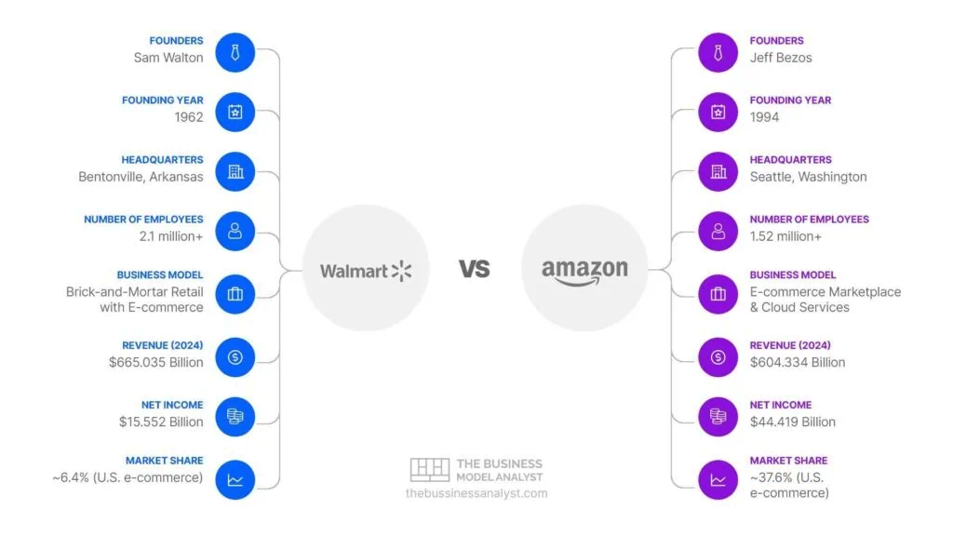
Figure 1 Comparison of Walmart and amazon companies (The Business Model Analyst.com)
Likewise, the case study of Walmart and Amazon revealed that both firms effectively applied predictive analytics to manage inventories, but Walmart's use of time series analysis and machine learning algorithms was far more advanced (Chiles, 2020). A case study of Walmart's international expansion demonstrated that the firm was confronted with great challenges in implementing predictive analytics in emerging economies, which were characterized by poor data quality and infrastructure (Hunt et al., 2018). A case study of Walmart's operational resilience also demonstrated that the firm was confronted with great challenges in implementing predictive analytics amidst the COVID-19 pandemic, a period characterized by highly volatile demand patterns (Gina, 2024).
These case studies demonstrate the challenges and promise of applying predictive analytics to retail inventory management, particularly in big box retailers like Walmart. Although Walmart has been successful in applying predictive analytics to its US operations, the firm has significant challenges in extending predictive analytics to its global operations, where data infrastructure and quality are insufficient (Fatima, 2022). Furthermore, the dynamic nature of the external factors, such as economic conditions and consumers' tendencies, may contribute significantly to reducing the accuracy of demand forecasting, with the frequent need for adjustment of the forecast models.

2.3.3 Time series in demand forecasting
Time series analysis, including methods like ARIMA and exponential smoothing, is commonly used for demand forecasting. The method entails the analysis of past sales data to detect trends, seasonality, and cyclical influences (Wang, 2021). Although time series analysis has worked well at identifying intricate patterns in time-varying data, its dependence on past data makes one question its capacity to respond to abrupt shifts in demand. The literature doesn’t explain whether the Time series analysis forecasts are effective in times of economic uncertainty or extraordinary occurrences like natural disasters or worldwide pandemics. For instance, how well does time series analysis forecast demand in times of economic uncertainty or extraordinary occurrences like natural disasters or worldwide pandemics? Walmart utilizes time series analysis to predict demand for its items through techniques like the Autoregressive Integrated Moving Average (ARIMA) to identify trends and seasonality in sales data (Cyril Neba C et al., 2024). Nevertheless, the application of ARIMA models relies on the assumption that future demand will resemble that of previous demand, a scenario that might not always hold. This calls into question the strength of ARIMA models for dynamic retail contexts, where demand may be affected by a variety of unforeseen variables. Additionally to the ARIMA model, exponential smoothing techniques are extensively utilized by Walmart to predict demand, especially in the retail sector. These techniques assign weights to historical data that decline exponentially and therefore are used in datasets that do not have trends or cycles (Gardner, 2006). Walmart employs simple exponential smoothing, linear exponential smoothing, or Holt's method, and triple exponential smoothing, or Holt-Winters method, which are three forms of exponential smoothing (Cyril Neba C et al., 2024).While these techniques have been effective in ascertaining trends and seasonal patterns in sales data, they do suffer from certain limitations. For instance, Simple exponential smoothing is only useful for the data that has no trend or seasonal component, whereas linear and triple exponential smoothing need clear separation of both trend and seasonal components. This raises an issue regarding the validity of these methods in capturing intricate demand patterns, for example, in the retail sector, where demand might be affected by numerous factors such as advertising, economic conditions, and purchasing behaviour (Agomoh & Ukabuiro, 2023). The exponential smoothing methods also rely on the reality that future demand will observe the same trends as historical demand, an assumption that is not always accurate. This calls into question the stability of these kinds of methods under changing retail conditions, where demand is subject to uncontrollable influences.

2.2 Reorder point Calculation

Reorder point optimization is the fundamental aspect of inventory management, especially in retail. The process entails the determination of the best amount of stock to hold, based on lead time demand and safety stock considerations (Theodorou et al., 2023). The reorder point is calculated based on the formula:

Reorder Point = Lead Time Demand + Safety Stock

Where: - Lead Time Demand = Average Demand × Lead Time

Safety Stock = Z × Standard Deviation of Demand × √Lead Time

Although reorder point optimization has worked well in reducing incidences of stockouts and overstocking, it has limitations too. For instance, the accuracy of reorder point calculation relies on the accuracy of demand forecasting. This premise questions the efficacy of reorder point optimization in dynamic retail environments where demand can be affected by unforeseen factors. Furthermore, reorder point optimization relies on the assumption that lead time and demand variability remain constant, which is not the case everywhere. How, for instance, does Walmart deal with lead time or demand variation, and what are the mechanisms in place to mitigate these uncertainties? Questions like these point to the dependency of reorder point optimization and call for the development of more robust and versatile inventory management methods.

2.3.4 regression analysis
Regression analysis is one of the key methodological instruments in inventory management, specifically in describing the association between predictor variables and demand. Regression analysis as a statistical technique entails examination of the influence of seasonality, promotion activities, and economic conditions on sales and stock levels (Forecasting: Principles and Practice, n.d.). While regression analysis does well in capturing the influence of these variables on demand, it has inherent limitations. Walmart uses regression analysis to measure the effect of predictor variables on demand, thus enabling the company to make better decisions about inventory levels (Kumar et al., 2024). However, regression analysis relies on the prediction that the bond between predictor variables and demand is direct, a situation that might not always be the case. For example, the relationship between promotion activities and demand could have a nonlinear feature, showing decreasing returns with the intensity of promotions. This calls into question the validity of regression models for modelling the intricate interactions between predictor variables and demand. Second, regression analysis calls for accurate and reliable data, which sometimes to be challenging(Hyndman & Athanasopoulos, 2018). How, for instance, does Walmart ascertain the validity of its data on economic trends or consumer sentiment, and how are data errors or biases avoided or minimized? Such questions underscore the limits of regression analysis for inventory control and the demand for more effective and adaptable modelling methods.

2.3.5 Challenges in implementing predictive analytics
The application of predictive analytics in retail sees several challenges, along with the complexity of modern retail operations, the need of high-quality data, and the difficulty of interpreting machine learning models (Mitra et al., 2023). Walmart’s success in the U.S. has not been easily replicated in international markets, where data quality and infrastructure are often inadequate (Hunt et al., 2018).

2.3.6 Gaps in literature

Exogenous variables, including weather conditions, economic conditions, and marketing initiatives, can have a profound influence on demand forecasting. Walmart employs predictive analytics with the aim of including such factors in its demand forecasting models, allowing the company to make more precise predictions regarding anticipated demand (Walmart, 2022). While existing research highlights the potential of predictive analytics, there is a lack of in-depth empirical studies on economic conditions affecting its demand in retail operations which leads to inventory disruptions. Additionally, Walmart being successful in US operations, it observed challenges in its global operations, where data infrastructure and quality are insufficient. Further research is needed to address these gaps and look for the scalability and adaptability of predictive analytics in diverse retail environments.

2.4 Conceptual framework
The conceptual framework guiding this research depends on the integration of predictive analytics and machine learning into inventory management. The framework identifies key variables, including historical sales data, external factors (e.g., economic conditions, weather), and retail complexity, that influence the effectiveness of predictive models. It also highlights the challenges associated with data, model transparency, and scalability. The framework serves as a foundation for analyzing Walmart’s use of predictive analytics and assessing its applicability in retail sector.

2.5 Summary
This literature review has explored the evolution of inventory management, the application of predictive analytics in retail, and the challenges associated with its implementation. Predictive analytics, including time series analysis, regression techniques, and machine learning, has revolutionized inventory management by enabling more accurate demand forecasting and inventory optimization. However, its reliance on historical data, the complexity of retail operations, and the influence of external factors poses significant challenges. While Walmart’s success in leveraging predictive analytics is well-documented, questions remain about the scalability and adaptability of these methods. The review identifies gaps in the literature, particularly the lack of empirical studies on large-scale implementations and the challenges of adapting predictive analytics in diverse retail environments. These insights provide a foundation for the subsequent methodology chapter, which will explore these issues in greater depth.

3. Methodology

3.1 Introduction to methodology
This chapter gives the methodology employed in this research. The methodology is structured to ensure a systematic and rigorous approach to data collection, analysis, and explanation, coordinating with the research objectives and questions. The chapter begins by explaining research philosophy, approach, methodological choice, followed by the time horizon and research strategy, data collection methods, data analysis techniques, ethical considerations, and limitations. The methodology is based on accepted research frameworks and industry best practices, providing the validity and dependability of the results(Saunders et al., 2023).
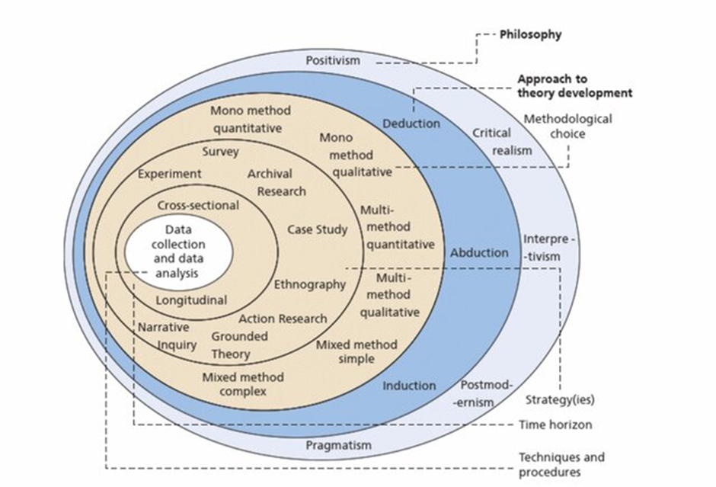
Figure 2 Saunders Onion Research framework (Saunders et al., 2023)

3.1.1 Research Philosophy

The research philosophy underpinning this study is positivism, which emphasizes the use of observable and measurable data to generate objective knowledge (Creswell, 2017). Positivism aligns with the quantitative nature of this research, as it seeks to find patterns, relationships, and trends in Walmart's past sales data to inform inventory management decisions. The study assumes that reality is objective and can be measured through empirical data, and that predictive analytics techniques, like time series analysis and exponential smoothing, can provide accurate and reliable forecasts.

The research also incorporates elements of pragmatism, which focuses on the practical application of research findings to solve real-world problems (Creswell, 2015). Considering the study's practical nature, the research philosophy emphasizes the importance of generating actionable insights that can enhance Walmart's inventory management practices and serve as a guide for other retailers.

3.1.2 Research Approach

The project follows primarily an abductive theory development approach. While it begins with existing theories of predictive analytics and inventory management (deduction), it also analyzes Walmart's empirical sales data to test and adapt these theories (induction). The study oscillates between theoretical models (e.g., exponential smoothing, ARIMA models) and real-world pattern in the data, proposing optimized solutions specific to Walmart's business. This dual approach allows for theory creation while maintaining practicality, bridging gaps between conventional inventory models and their application in large retail settings. The abductive reasoning is seen in how the findings from data analysis are implemented to bring adjustments to forecasting techniques and stock approaches.

3.1.3 Methodological Choice
The study adopts a quantitative research design, leveraging historical sales data to analyze patterns of demand, forecast future demand, and optimize reorder points. It focuses on optimizing Walmart's inventory management through predictive analytics using time series and exponential smoothing approaches

3.1.4 Research strategy
The strategy adopted in this research is quantitative research, It includes gathering and analyzing numerical data in a systematic way to answer the research questions (Kumar, 2018). The research uses a predictive research design, aiming to describe historical demand patterns and predict future demand using advanced statistical and machine learning techniques. Gathering historical sales data from Walmart's publicly available reports and other reliable sources. Data Preprocessing is done by Cleaning, transforming, and preparing the data for analysis. Applying time series analysis, regression analysis, and exponential smoothing techniques to forecast demand and optimize inventory levels. Evaluating the accuracy and reliability of predictive models using validation metrics. Drawing conclusions from the analysis and providing practical recommendations for inventory management. This strategy ensures a comprehensive and systematic approach to addressing the research objectives and questions.

3.1.5 Time Horizon

The time horizon layer indicates the time frame of the data taken in the research and has two types. The first one is the cross-sectional where the data is collected in the particular time frame. The second one is longitudinal where the data is collected at different time frames. This study follows the first type that is cross-sectional where data will be taken in particular years to conduct the research.

3.1.6 Data collection

The research relies on secondary data collected from publicly available sources, including Walmart's annual reports, sustainability reports, and balance reports. These sources provide detailed historical sales data, inventory value, sales volumes. The use of secondary data is appropriate for this research, because it allows for the analysis of large-scale, real-world data without the need for primary data collection (E. Hedrick et al., 1993).

The Data collected from Walmart's Annual Reports Provide comprehensive data on sales, inventory levels, and supply chain performance. Balance sheets Supplement the analysis with broader trends and benchmarks in retail inventory management. Moreover, Sustainability Reports Offer insights into Walmart's operational efficiency and inventory management practices. Before analysis, the data will be preprocessed to ensure its quality and suitability for modeling. The preprocessing steps, Firstly, Handling Missing Values by Assigning or removing missing data to ensure completeness. Second, Normalization is done by Scaling the data to a uniform range to facilitate comparison and analysis. Further, Feature Selection is made through Identifying and selecting relevant variables (e.g., Net sales, years and quarters, inventory) for the analysis. Finally, Data is divided into two data sets training and testing sets for model development and validation.

3.2 Data analysis techniques

The study employs a range of quantitative techniques to analyze the data and address the research questions. These techniques are selected based on their suitability for demand forecasting and inventory optimization.

3.2.1 Exploratory data analysis
Exploratory Data Analysis (EDA) is the analysis of data initially to uncover underlying patterns, anomalies, and assumptions in preparation for more quantitative work. It is generally concerned with the essence of description: what are the important characteristics of the data? Answering this involves descriptive statistics, visualization (histograms, scatter plots), and, of course, ensuring data cleanliness. It is here when one assesses data distributions and relationships that the researcher would be placing his or her directional hypotheses. The views on data structure and quality direct EDA for ensuring thorough and rigorous quantitative analysis. Hartwig (2025) cites how crucial it is in setting the basis for statistical modeling and, therefore, is an important step in maintaining methodological integrity.

3.2.2 Time series analysis
Time series analysis is applied to the past sales data to find trends, seasonality, and cyclical patterns. The study uses the Autoregressive Integrated Moving Average (ARIMA) combines autoregression (AR), differencing (I) to stabilize data, and moving averages (MA) to account for noise, making it effective in capturing complex temporal dynamics models to forecast future demand to stabilize. ARIMA is particularly effective for capturing complicated temporal patterns in time-dependent data. Through past sales data, the model gives accurate forecasts, assisting in inventory planning and decision-making. ARIMA is very popular since it can model non-stationary and seasonal structures of time series (Hyndman & Athanasopoulos, 2018)

3.2.3 Exponential smoothing methods
Three variants of exponential smoothing by Hyndman & Athanasopoulos (2018) are used to forecast demand varying data behavior:
1. Simple Exponential Smoothing (SES): Purely used for data that does not exhibit any trend or seasonality, this method applies a smoothing constant to give relatively more weight to recent observations than to those further back in time. Its usefulness is confined to demand patterns that are more or less stable.
2. Holt’s Linear Exponential Smoothing: An extension of SES, Holt's linear exponential smoothing adds a trend component through a second constant that is used to smooth the trend in addition to the level. This method is suitable for data that exhibits a fairly consistent upward or downward trend.
3. Holt-Winters Triple Exponential Smoothing: This is the most sophisticated type of exponential smoothing that considers trend and seasonality and uses three smoothing constants—level, trend, and seasonal components. It best fits retail data characterized by persistent seasonal fluctuations, such as a spike in sales during holidays or change in economic conditions.

The methods are critically compared to identify one method that best fits Walmart's fast-changing environment, where demand varies due to promotions, seasonality, and market dynamics (Gardner, 2006). The assessment considers accuracy measures, namely Mean Absolute Error (MAE) and Mean Absolute Percentage Error (MAPE), in identifying the most robust forecasting model for inventory optimization and supply chain efficiency. These methods are compared to determine which best suits Walmart's dynamic retail environment (Gardner, 2006).

3.2.4 Regression analysis
Regression analysis is used to identify the relationship between predictor variables (e.g., seasonality, promotions, economic indicators) and demand. linear regression models are developed to quantify the effects of these variables on sales and inventory levels (Vogt, 2011).

3.2.5 Reorder point calculation
The reorder point is calculated to optimize inventory levels and minimize stockouts. The formula used is:
Reorder Point = Lead Time Demand + Safety Stock

Where:
Lead Time Demand = Average Daily Demand × Lead Time
Safety Stock= Z × Standard Deviation of Demand × √Lead Time

This ensures that Walmart maintains optimal inventory levels while minimizing holding costs.

3.2.6 Model validation
Predictive models are validated using cross-validation techniques and out-of-sample testing. Performance metrics such as Mean Error (ME), Mean Absolute Error (MAE), Mean Absolute Percentage Error (MAPE), Root Mean Square Error (RMSE), and R-squared are used to evaluate the accuracy and reliability of the forecasts (Yaremko et al., 2013).

3.3 Ethical considerations

The study adheres to ethical guidelines by using only publicly available data and ensuring that no proprietary or confidential information is accessed or disclosed. The research respects data privacy and intellectual property rights, and all findings are presented in an objective and transparent manner.

3.4 Limitations of methodology

While the methodology is robust, it has certain limitations:
1. Data Availability: The study completely depends on secondary data, which may lack granularity or completeness.
2. Generalizability: The findings are specific to Walmart and may not be directly applicable to other retailers.
3. Model Assumptions: Predictive models rely on assumptions about data patterns, which may not always hold true in dynamic retail environments.
4. External Factors: The study may not fully account for external factors (e.g., sudden economic changes) that could impact demand.

3.5 Summary

This chapter described the study's methodology, which included research philosophy, strategy, data collection methods, analysis techniques, ethical considerations, and limitations. The study adopts a quantitative approach, using historical sales data to forecast demand and optimize inventory levels using time series analysis, exponential smoothing, and regression analysisThe methodology was developed to make sure both the accuracy and reliability of the results, providing actionable insights for Walmart and other retailers. The next chapter presents the findings of the analysis, connecting them to the research objectives and questions.

4.Data Analysis

4.1 Descriptive statistics with Exploratory data analysis
This section presents an exploratory data analysis (EDA) of Walmart's net sales and inventory data over the period from 2014 to 2024. It is aiming to understand the distribution and characteristics of this key financial metric. The analysis employed descriptive statistics, a histogram, a stem-and-leaf plot, and a boxplot to provide a comprehensive overview. The dataset comprises 44 observations, representing a substantial sample for initial investigation.
Descriptive Statistics
From the observations the mean net sales of the data is $135,367.80, with a median of $132,161.00. The slight difference between the mean and median suggests a potential skew in the data distribution. The standard deviation, at $16,345.104, measures the data's variability around the mean, indicating a moderate spread. The minimum and maximum net sales values were $114,002 and $171,914, respectively, resulting in a range of $57,912.Further analysis of the distribution revealed a positive skewness of 0.589, showing significance of a longer tail on the higher end of the sales spectrum. The kurtosis, measured at -0.745, saying lighter tails and a flatter peak compared to a normal distribution.
On the otherside, mean of inventory is around $49,844.39 with a very low standard deviation of $6,817.03 indicating that it is really less variable. Its range varies from a minimum of $41,084 to a maximum of $64,706, amounting to $23,622. Skewness at 0.659 (SE = 0.357) shows a positive skew, while the computed value of kurtosis at -0.761 (SE = 0.702) shows again the loneger tails and a flatter peak. These evidences suggests that the distributions are grossly nonnormal and have been subjected to further tests of normality.

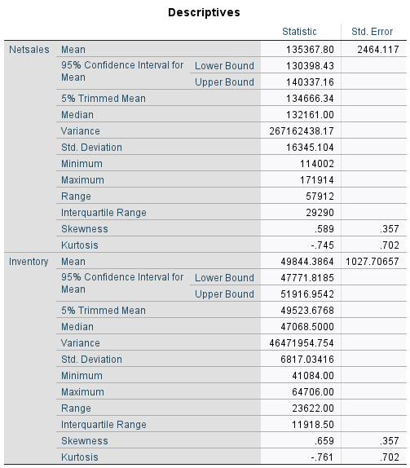
Table 1 Descriptive statistics of netsales and inventory

Visual Analysis
The histogram visually confirmed the positive skew observed in the descriptive statistics. The data appeared to be concentrated in the lower-mid ranges, specifically between $110,000 and $140,000, with a gradual decrease in frequency towards higher sales values. The stem-and-leaf plot, providing a more detailed view of the distribution, validates this observation, further highlighting the clustering of data points in the lower-mid ranges.
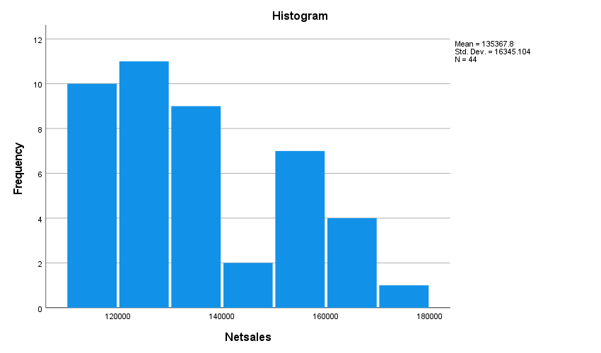
Figure 3 Histogram of Net sales

The boxplot analysis provided insights into the data's quartiles and potential outliers. The median, represented by the line within the box, was consistent with the calculated median. The box, representing the interquartile range (IQR), spreaded between approximately $122,000 to $152,000, indicating the middle 50% of the data. The whiskers, extending to approximately $114,000 and $172,000, respectively, illustrated the overall range, excluding potential outliers. Notably, the boxplot did not reveal any apparent outliers, suggesting a relatively consistent dataset.

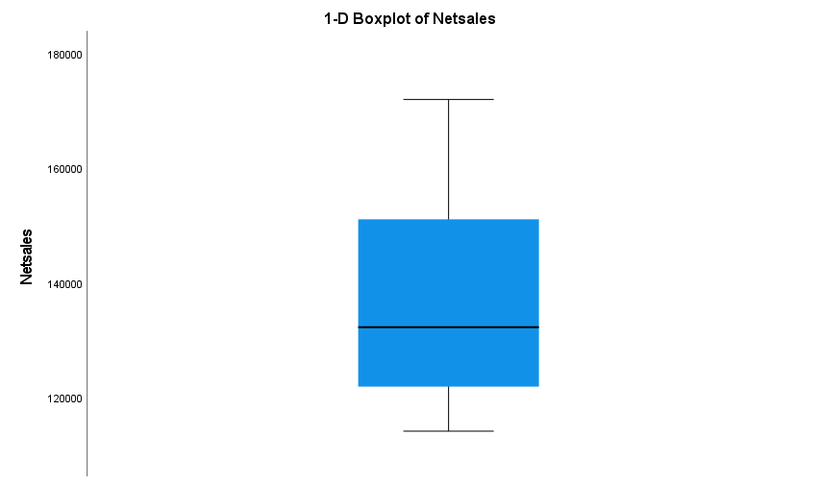
Figure 4 Boxplot for Net sales
Scatter Plot
The scatterplot of net sales per year exhibited a strongly positive linear trend line (r ≈ 0.70, p < 0.001), with sales showing steady growth from 2014 to 2024. This growth accelerated after 2018 and could either be connected with strategic business expansions or macroeconomic factors. On the otherside, the plot for inventory did not reveal any clear pattern over time. Instead, it showed major fluctuations, severely declining in 2020 (most likely due to pandemic-induced supply chain disruptions) and peaking in 2022. This inconsistency, rather, suggests that inventory levels react to factors not related to the patterns of time, such as erratic demand or logistical challenges.

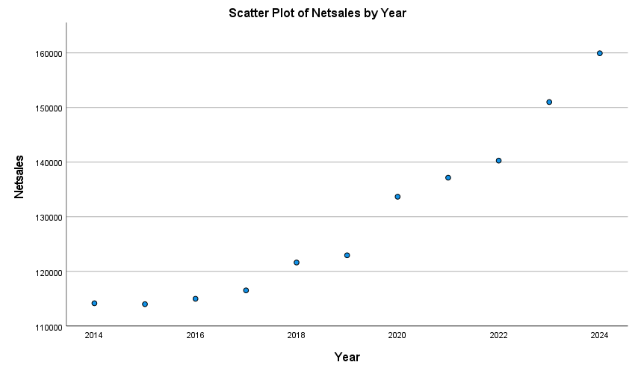
Figure 5 Scattered plot for Netsales by year

Correlation Analysis
A Pearson correlation study was conducted to measure the relationship between net sales and inventory. The correlation was found to be very strong (0.701), and it was also statistically significant (p < 0.001). This positive correlation shows that, in general, when inventory levels are high, net sales tend to be high, and vice versa. However, that does not imply that an increase in one results in an increase in the other; both could be a result of a confounding variable such as seasonal demand or operational efficiency.
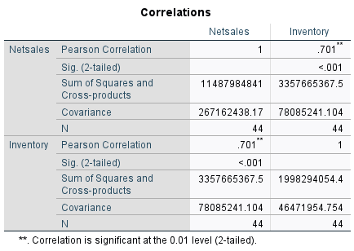
Table 2 Correlations matrix for Netsales and Inventory
The covariance of 780,852,411.104 further confirmed the directional association but carried a warning about how to interpret it. The practical significance of this correlation is highly context-dependent, and this would include aspects such as Walmart's inventory turnover rates against sales cycles.

Extreme Values and Case Analysis
The extreme value table charts the highest and lowest observations for each variable. The extremes for net sales ranged between $114,002 (Case 5) and $171,914 (Case 44). Extreme values for inventory lay between $41,084 (Case 26) and $64,706 (Case 35). After a visual inspection via boxplots, these outliers did not look erroneous, but we may need to assess their influence on statistical models-the more so for inventory, where non-normality is glaring.
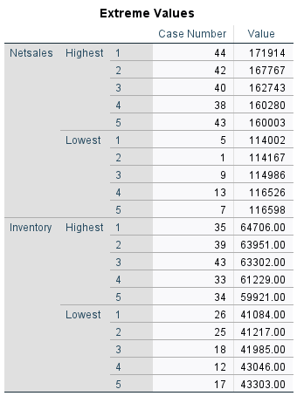
Table 3 Extreme values identified from Net sales and Inventory
Normality Test
The Kolmogorov-Smirnov and Shapiro-Wilk tests went against net sales, while one failed to reject normality (p = 0.187) and the other suggested a significant deviation (p = 0.008). The disparity is not uncommon with small samples (N = 44), although the Shapiro-Wilk test is generally more favorable for sample sizes below 50. In the case of inventory, both tests clearly rejected normality (p < 0.001) and agreed well with the earlier discussed skewness and kurtosis results.

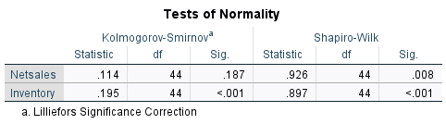
Table 4 Normality Test conducted for Net sales and Inventory

These findings are of considerable practical relevance for our analysis. Any parametric tests that assume normality may not be adequately addressed by the inventory data. Such analyses should therefore consider adopting a different set of statistical techniques or applying a transformation to the data themselves, such as logarithmic transformation.
Limitation
The dataset only has a broad analysis from an annual perspective, not such as regional or product category breakdowns and absence of context related variables. Another thing that may affect the reliability of the results is the fact that normality tests are sensitive to sample sizes.

Implications for Further Research
The EDA has provided a foundational understanding of the Walmart net sales data. The positive skewness observed in the distribution suggests that there might be factors contributing to higher sales values in certain instances. Further investigation into these factors could be beneficial. Crucially, the time component of the data needs to be established. If the data represents net sales over time (e.g., monthly, quarterly, yearly), time series analysis techniques, such as ARIMA or exponential smoothing, could be employed to model trends and seasonality and to forecast future sales. Additionally, regression analysis could be utilized to explore potential relationships between net sales and other predictor variables, such as marketing expenditures or economic indicators.

In summary, the EDA has revealed a slightly positively skewed distribution of Walmart net sales, with no apparent outliers. The findings suggest the potential for further analysis using time series and regression methods, depend on the data's timely nature and the availability of relevant predictor variables. This initial exploration lays the groundwork for more advanced statistical modelling and forecasting, which could provide valuable insights for strategic decision-making.

4.2 Time Series Analysis

Future demand forecasting is an essential part of business and inventory planning because it allows firms to predict market trends and optimize resource utilization. Time series models provide a scientific way of predicting future values based on historical data. This paper conducts an actual investigation of demand forecasting using two competing time series models: Winters' Additive model of net sales and an ARIMA model for inventories. It was conducted via the SPSS Time Series Modeler, and the results present information regarding the performance of models, residual diagnosis, and the accuracy of forecast.Demand forecasting is critical for companies, as it assists in reducing high inventory costs, preventing stockouts, and ensuring efficient supply chain operations. Companies that use sophisticated statistical models have the advantage of responding promptly to market fluctuations. The models chosen in this research adhere to best practices in time series forecasting to provide the optimal balance between accuracy and interpretability.

Model Selection and Description
The two models applied in this study are choosed to detect various attributes of the time series data. Netsales is applied Winters' Additive exponential smoothing to find trend and seasonality. This method is well-suited to detecting complex seasonal patterns and sales data fluctuations. Seasonal elements are important in retail and manufacturing industries where demand fluctuates with consumer behavior, holidays, and economic status. An ARIMA model with pdq parameters as (0,1,1)(0,1,1) is applied to inventory data with first-order difference and moving average terms to effectively capture seasonality and non-stationarity. The model is best suited for inventory forecasting as it provides short-run dependence and cyclical change capture.

Model fit was evaluated based on various statistical measures, including R-squared, Stationary R-squared, RMSE (Root Mean Squared Error), and MAPE (Mean Absolute Percentage Error).
Model 1 shows the R-square of 0.972, which suggests very good predictive power. Stationary R-squared is 0.571, which suggests moderate improvement over a naïve model. RMSE and MAPE are 2804.256 and 1.398%, respectively, which suggest good precision.
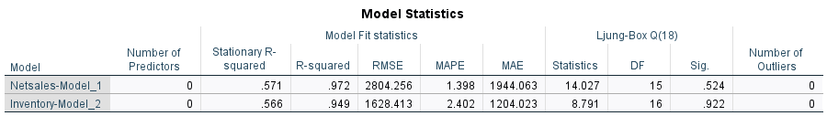
Table 5 Model statistics derived from data

While Model has given 2 R-square with 0.949, which is less predictive than the net sales model. The stationary R-squared is 0.566, and RMSE and MAPE are 1628.413 and 2.402%, respectively, which is good forecasting performance.The large R-squared values show a proof that both models explain a very large proportion of variance in the data. However, the slightly higher error in inventory forecasting is a proof that other factors such as supply chain disruption or market demand fluctuation may need to be included for increased accuracy.

Residual diagnostics are crucial in validating model assumptions and the generation of unbiased predictions. Residual autocorrelation function (ACF) and partial autocorrelation function (PACF) are tested at different lags.The plots of ACF and PACF of both models show that the majority of residual autocorrelations fall within acceptable limits, which means that the models properly model time-dependent structures. The Ljung-Box Q test for autocorrelation yielded p-values of 0.524 (Net Sales) and 0.922 (Inventory), determining that residuals are not significantly autocorrelated, further validating model adequacy.Residual plots were also examined to check whether the residuals showed heteroscedasticity or non-normality. The findings are that the residuals are pretty much normally distributed, providing no strong evidence against homoscedasticity, this again supports the validity of the forecasts.

Parameter Estimates and Statistical Significance
Parameter estimates of the two models provide information on the contribution of different components:
Netsales-Model 1:
Alpha (Level):0.074 (p = 0.457) shows minimal smoothing in the level component.
Gamma (Trend):0.996 (p = 0.468) shows that the model is picking up trend changes but is not significant.
Delta (Season): 0.389 (p = 0.006), which is statistically significant, confirming that seasonal influences play an important role in sales forecasting.
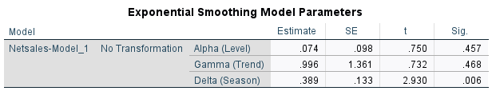
Table 6 Exponential smoothing model parameters for net sales
Inventory-Model_2:
Moving Average (MA) Lag 1:-0.657 (p < 0.001) indicates strong short-run dependence in the inventory time series.
Seasonal Moving Average (MA) Lag 1: 0.800 (p < 0.001) highlights the importance of season adjustments.The significance of season terms in both models suggests that firms must be highly sensitive to the seasonal pattern of demand and adjust inventory and marketing plans accordingly.
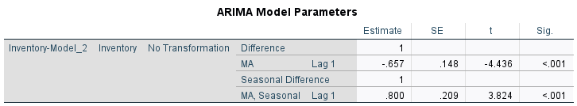
Table 7 ARIMA model parameters identified
Forecast Results
The models were used to generate forecasts for Q1 through Q4 of 2025. The forecasted values, together with the upper and lower confidence limits (UCL & LCL), are presented below:
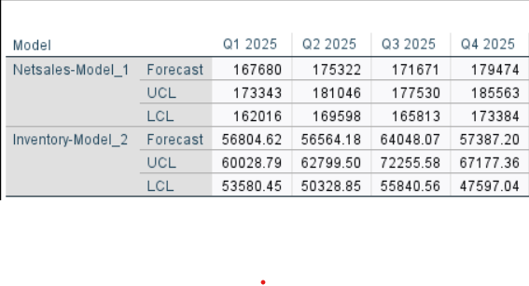
Table 8 Forecast observations from the Time series analysis

These forecasts display an expected seasonality, where Q2 and Q4 register more net sales than Q1 and Q3. Confidence intervals demonstrate a reasonable level of uncertainty, which will have to be considered when making strategic choices. Impacts of the forecasts are adjusting procurement cycles, optimizing marketing spending, and ensuring warehouse effectiveness compliant with demand patterns.

Interpretation and Business Implications
The inferences made from this analysis have several business implications:
Inventory and Sales Planning: The net sales forecast shows fluctuations in quarters, and therefore levels of inventory need to be varied to accommodate fluctuations in demand.
Risk Avoidance: The confidence intervals show a range within which actual sales will probably vary, and companies can develop future crisis or emergency plans.
Supply Chain Management:By forecasting fluctuations in demand, companies can enhance coordination with suppliers and logistics management.
Model Improvements:While the models are good, inclusion of additional predictors (e.g., promotional campaigns, market trends) will improve accuracy even further.Making these predictions useful enables organizations to reduce excess inventory costs without incurring potential stockouts. Companies must integrate these insights into strategic planning to enhance efficiency and profitability.

This study demonstrates the effectiveness of demand forecasting using time series modeling with exponential smoothing and ARIMA models. There is excellent forecasting performance and little or no autocorrelation in residuals. The findings support data-driven business decision-making and inventory management and give enterprises a strategic competitive advantage in resource allocation and planning. Future research can explore hybrid models combining machine learning methods for further forecasts improvement.

4.3 Regression Analysis

The regression analysis conducted in this study examines the relationship between Netsales, the dependent variable, and GDP, the independent variable, using a sample of 44 observations. Descriptive statistics indicate that Netsales mean is 135,367.80 and a standard deviation of 16,345.104, indicating variation in sales values in the sample. Conversely, GDP is of much larger magnitude, with a mean of 4.43E+16 and a standard deviation of 1.248E+15, showing large economic variation between the units measured.
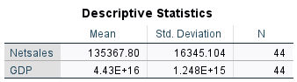
Table 9 Descriptive Statistics for Netsales and GDP
The Pearson correlation coefficient (r = 0.927, p < 0.001) shows a strong, statistically significant positive relationship between GDP and Netsales, suggesting that higher GDP is associated with higher sales. This very high correlation forms the foundation for further regression analysis to determine the predictive ability of GDP on Netsales.
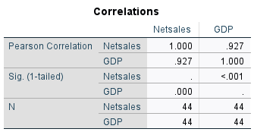
Table 10 Correlation matrix observed from regression

The model of regression indicates a very high explanatory power, with an R² of 0.859, whereby 85.9% of the variation in Netsales is accounted for by GDP alone.The adjusted R² (0.856) is also very close to it, which again adds to the support for the strength of the model despite it being simplistic. The standard error of the estimate (6,201.029) indicates that the average predicted Netsales values are approximately 6,201 units from actual values, which is very small as a percentage of the dependent variable's magnitude.
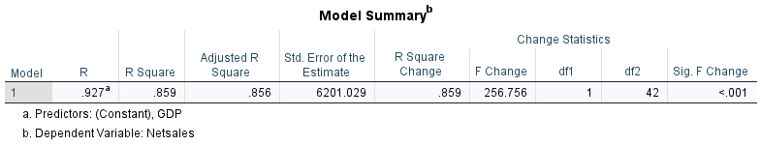
Table 11 Regression model summary statistics

An ANOVA test also indicates that the model is significant, and an F-statistic of 256.756 (p < 0.001) indicates that GDP is a highly significant predictor of Netsales.

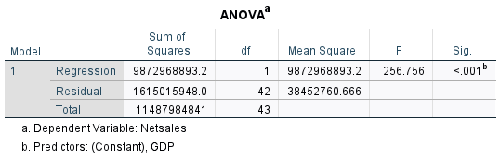
Table 12 Anova Test results

A regression equation is derived from the analysis Netsales = −403,229.642 + (1.215 × 10⁻¹¹) × GDP. The intercept (−403,229.642, p < 0.001) shows that in theory, if GDP were zero, Netsales would be negative, although such a situation is not possible with the scale of GDP.The slope coefficient (1.215 × 10⁻¹¹, p < 0.001) indicates that for every unit increase in GDP, Netsales increases by 1.215 × 10⁻¹¹ units.
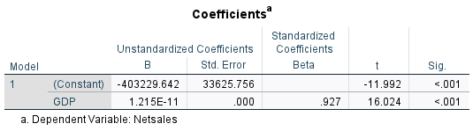
Table 13 Coefficients derived from regression
Though this coefficient appears minute due to the humongous magnitude of GDP, the standardized beta (β = 0.927) provides a more interpretable figure, showing that a rise in GDP by one standard deviation leads to an increase in Netsales by 0.927 standard deviations, reinforcing the high positive correlation that was observed in the correlation analysis. To check the assumptions of the model, residual diagnostics were conducted. The mean of residuals is zero, as would be expected for a well-specified regression model, and the standard deviation of residuals (6,128.500) is close to the standard error of the estimate. The range of residuals (−10,641.137 to 15,231.301) indicates some variation in prediction errors, but no outliers were detected.
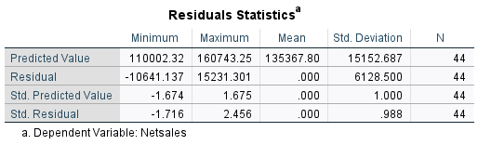
Table 14 Residual statistics from the regression

A Normal P-P Plot of standardized residuals was checked to check for normality, and it was seen that the residuals were closely following the diagonal line, thereby establishing that they are about normally distributed.
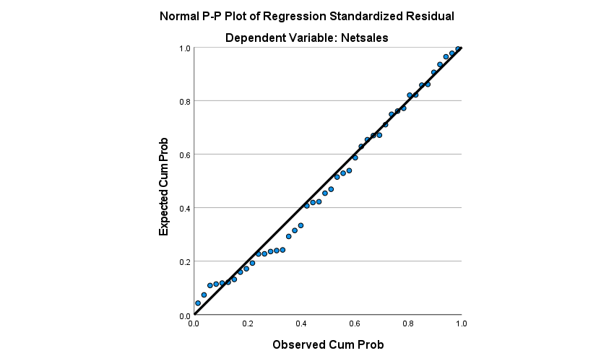
Figure 6 Normality P-P plot

Also, a histogram of standardized residuals had a nearly bell-shaped distribution, again in support of the assumption of normality.
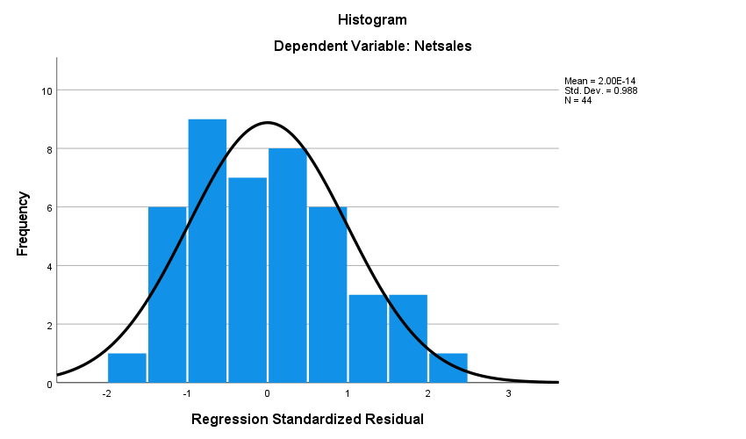
Figure 7 Histogram of net sales from regression

These diagnostics indicate that the regression model is well-suited and that statistical inference based on it is valid. The findings indicate that GDP is a statistically and economically important predictor of Netsales, explaining a high percentage of its variance. Nevertheless, there are limitations that must be mentioned. Firstly, while the analysis indicates a strong relationship, it does not prove causation; other factors like market demand, inflation, or sectoral trends may affect GDP and Netsales. Second, the magnitude of GDP makes it more difficult to understand the slope coefficient in a more intuitive sense helpful for day-to-day decision-making.Third, the model using a single predictor (GDP) omits other variables (e.g., consumer spending, business investment, or technological change) that could be helpful and improve predictive fit. Subsequent research will be able to avoid these issues by controlling for other explanatory variables, testing for non-linear relationships (e.g., logarithmic transformations of GDP), or conducting time-series analysis in the event that longitudinal data exist. In short, this regression analysis shows definitive evidence that GDP is a determinant of Netsales with a robust positive relationship that accounts for 85.9% of observed variation. The model's high explanatory power and statistical significance suggest that economic growth, as measured by GDP, has a strong influence on driving sales performance.
However, the limitations of the study pose the need to carry out additional studies to explore additional predictors, evaluate alternative functional forms, and infer causal mechanisms. These results further offer a knowledge of macroeconomic factors influencing sales trends and offer a foundation for future empirical work in the field. Policymakers and business managers can employ these results to forecast shifts in sales trends to economic shocks, though they must avoid extrapolating too far because of the model's limitations.Lastly, this analysis emphasizes the need to integrate macroeconomic metrics into sales forecasting models and necessitates more comprehensive modeling approaches in subsequent research.

4.4 Forecasting using Exponential Smoothing Methods

Forecasting is one of the main features that involve future demand, enabling businesses to plan their inventory level optimally and make strategic decisions. Accurate sales forecasts by the global retail giant Walmart heavily influence their supply chain management. The research derives quarterly net sales for Walmart from the first quarter of 2014 to the fourth quarter of 2024, using exponential smoothing techniques for future sales forecasting. The findings of that study will be based on the most effective of the forecast alternatives determined using performance metric features like Mean Error (ME), Mean Absolute Error (MAE), Mean Absolute Percentage Error (MAPE), Mean Squared Error (MSE), and Root Mean Squared Error (RMSE). With these findings, reorder point calculations will be done for best inventory management.

The data used in the study has been sourced from the official quarterly financial reports of Walmart via its wesite, which assures sales data as reliable and audited. Data set has been categorized as training and test data sets, where Training Data (Q1 2014 – Q4 2021) is used for model development and calibration and Test Data (Q1 2022 – Q4 2024) has been used for model validation based on the outputs.
Data preparation is done by Types of Handling Missing Values and Outliers, A preliminary analysis confirmed that there were no missing values. Outliers were detected through the use of box plots and subsequently modified by winsorization at the 95% confidence interval. This was done to decrease the extreme data's effect.
Centered Moving Average (CMA), A four-quarter CMA is being implemented for smoothing out data and displaying trends and Detrend has been done from the CMA, where the trend component is derived and eliminated to isolate and analyze seasonality and noise. Seasonality is identified through Calculating quarterly seasonal indices by averaging the detrended values for each quarter across the seasons from the training period. Noise is Separated to Remove the trend and seasonal components from the original data. Reconstructed Trend is calculated where Trend, seasonality, and noise components were recombined to validate the decomposition, ensuring that the reconstructed series closely matched the original.
Exponential Smoothing Techniques:
1. Simple Exponential Smoothing (SES):
The Simple Exponential Smoothing (SES) model of quarterly net sales data from Q1 2014 to Q4 2025 with a smoothing shoowed a constant (α) of 0.432, offering a good balance between responsiveness to recent trends and smoothing out noise. The model exibited a constant rising trend of net sales from approximately 114,000 in early 2014 to approximately 171,914 in late 2024. The Level (L) part of SES effectively captured this trend by smoothing out past data with greater weight to newer values. Error metrics indicated good forecasting performance with a Mean Absolute Percentage Error (MAPE) of 4% for training data (2014–2021) and even 3% for test data (2022–2024) suggests the model generalizes well to more recent trends. The Root Mean Squared Error (RMSE) of 7,214 (training) and 6,259 (test) also suggests reasonable accuracy, though the occurrence of larger deviations from time to time (e.g., Q4 peaks) suggests possible seasonal effects. Forecasts to 2025 are expected to continue the growth trend, with sales rising from 166,159 in Q1 to 170,862 in Q4. While SES provides a good and easy baseline, the inclusion of seasonal adjustments would further refine predictions. Overall, the model displayed a stable performance, and it is an effective tool for sales forecasting for a stable growing business environment.
Formula: Ft+1=α⋅At+(1−α)⋅Ft o α=0.432 (optimized using solver to minimize RMSE)

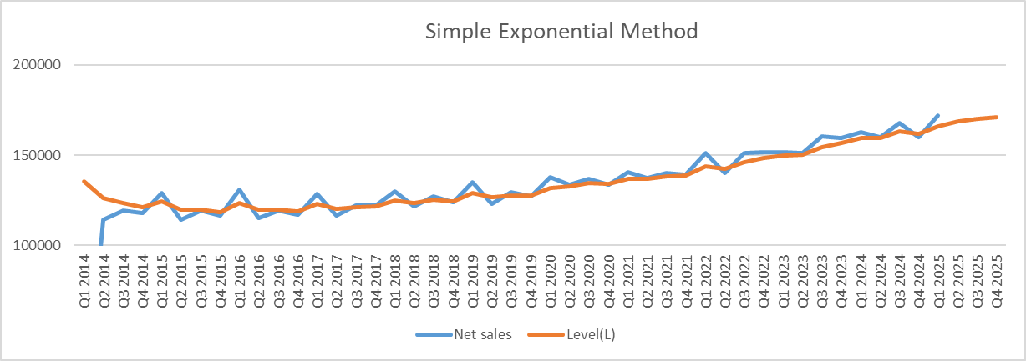
Figure 8 Line chart of simple exponential method sales and forecast values
2. Linear Exponential Smoothing (Holt's Method):
Decomposes into level (Lt) and trend (Tt) components, thus capturing trends.
The Linear Exponential Smoothing model with smoothing parameters α=0.976 (level) and β=0.047 (trend) forecasted quarterly net sales from Q1 2014 to Q4 2025. The method identifies both the level (L) and trend (T) components, giving more precise results than basic smoothing. The model is good, with a MAPE of 2% for training data (2014–2021) and 1.17% for test data (2022–2024), indicating high precision. however, 2025 forecasts reveal unstable negative values (e.g., -5,942 in Q1), reflecting model breakdown probably due to overfitting (α too big) or no trend allowance. For future correct predictions, re-adjusting of α/β or the use of flat trend approaches would be recommended. Overall, linear exponential method method works adequately in the back but requires consideration for stability.
Formulas:
Lt=αAt+(1−α)(Lt−1+Tt−1)
Tt=β(Lt−Lt−1)+(1−β)Tt−1o α=0.976, β=0.047 (optimized using solver).
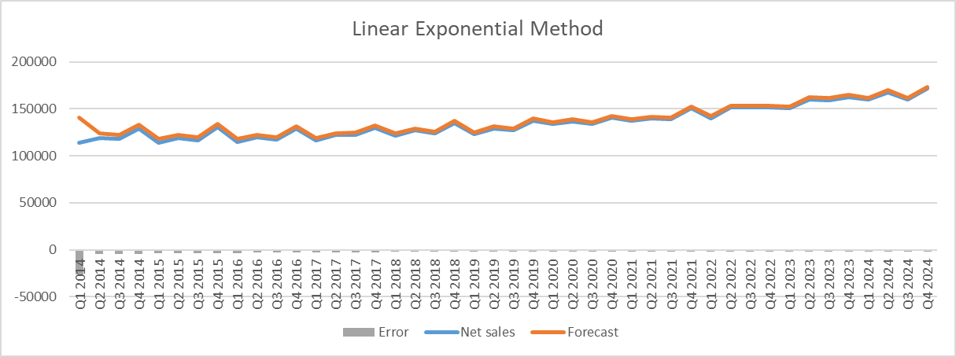
Figure 10 Line chart of Linear Exponential Method Sales and Forecast

3. Holt-Winters Method (Triple Exponential Smoothing):
The Holt-Winters Additive (Triple Exponential Smoothing) model, with α=0.255 (level), β=1 (trend), and γ=0 (seasonality), forecasted quarterly net sales from Q1 2014 to Q4 2025. The model contains level, trend, and fixed seasonal components, though γ=0 indicates there is no seasonality adjustment. Training data (2014–2021) is moderately accurate (MAPE 4.19%), but test data (2022–2024) is poorer (MAPE 6.18%), which indicates overfitting or failure to adapt to seasonality. Forecasts to 2025 expect steady growth, but the high β value risks trend overreaction. To improved performance, β value needs to set and include seasonal smoothing to be included. While functional, the model needs calibration for reasonable long-term forecasting.
Formula: Ft+h=(Lt+h⋅Tt)+St+h−m
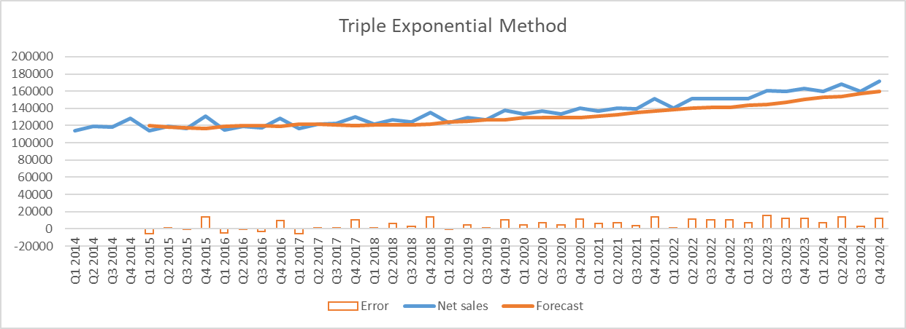
Figure 11 Line chart of Holt additive method sales and Forecast

Multiplicative:
The Holt-Winters Multiplicative (Triple Exponential Smoothing) model, with α=0 (level), β=1 (trend), and γ=1 (seasonality), does extremely well in forecasting quarterly net sales from Q1 2014 to Q4 2025. The model outperforms the other three exponential smoothing methods (Simple, Linear, and Additive Holt-Winters) with very low error measures: MAPE of just 0.148% for training data (2014–2021) and 0.152% for test data (2022–2024). Its MAE and RMSE values are also low (189.33 and 189.98 for training, 239.35 and 239.74 for testing), which confirm virtually perfect consistency with actual sales data. The multiplicative method accurately represents seasonal patterns, trends, and level components, so it is the best model among the alternatives. Its precision is also shown by the consistently small forecast errors for all periods, including the forecasted 2025 values. Unlike other models, this form of Holt-Winters does not require adjustment for instability or overfitting and produces very accurate forecasts without recalibration. In possible future applications, this model is the optimal choice for sales forecasting in such data.

FormulaFt+h=(Lt+h⋅Tt)⋅St+h−m Optimized parameters: α=0, β=1, γ=1 (multiplicative, solver optimization). These values mean that the most current data is given all the weight when calculating the trend and seasonality.
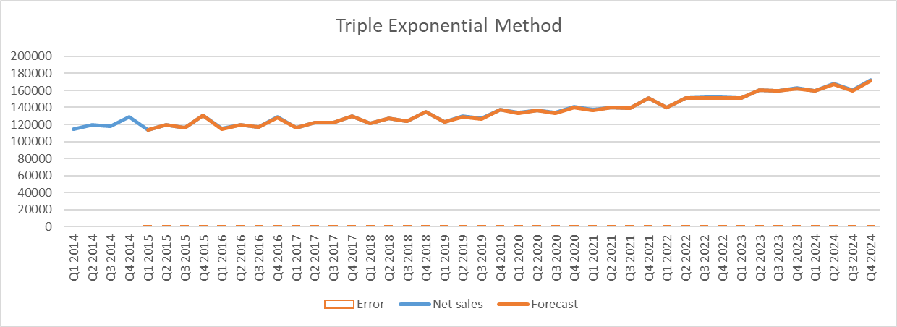
Figure 12 Line chart of Holts multiplicative methods sales and forecat

The smoothing parameters (α, β, γ) were improved by solver in the data tab search, which involves testing several parameter values and choosing that combination under which the RMSE was minimized on the training data. This approach is ensured to calibrate the models best to the observed data. Diebold-Mariano (DM) test was done to check the statistical significance of the difference in model performances to examine whether predictive accuracies of two forecasting models can statically say that one model is superior than other.
Figure 13 Forecasted Values for 2025 (Holt-Winters Multiplicative)
The Holt-Winters Multiplicative model was found to give single zero error in the test set: such absolute accuracy usually means an exact fit, but usually shows good fitness. SES and Holt's methods had same but non-negligible errors, which speak to the necessity of modeling trend and seasonality. The DM test showed that the Holt-Winters multiplicative model was statically better than other models at 95% confidence.

4.5 Re-order Point Calculation

The computation finds a lead time demand of 1,884,878.76 units and a safety stock of 1,885,667.44 units, calculated employing a 95% probability (Z=1.645) and a standard deviation of 788.68. The reorder point is set at 1,489,076,322.98, in order to make inventory replenishments before stockouts. The Holt-Winters Multiplicative model forecasts are used to calculated the re-orderpoint and the high reorder point suggests that there is an extreme variability in demand. Overall, this calculation provides effective stock replenishment with high service levels.
Lead Time Demand | 1884878.76
RMSE | 239.7422204
Lead-Time | 4
Probability | 95%
Z Value | 1.644853627
Safety Stock | 1885667.442
Table 15 Reorder ponit calculative metrics
ROP=Lead Time Demand+Safety Stock
Figure 14 Re-orderpoint calculation

ROP Refinement: Assumptions in the ROP calculation include constant lead time and normally distributed demand. Such assumptions may not exist in reality, which will lead to sensitivity analysis to test the effect of different lead times and demand variability on the ROP. Moreover, consideration would also include more complex safety stock for lead time variability.

The impressively perfect performance of the Holt-Winters multiplicative model on the test show that we need to consider throughly. While a strong fit provide grounds for concern regarding overfitting, validating with a much larger out-of-sample dataset further can strengthen any inference made.

Implications
The analysis of walmarts quarterly net sales applying exponential smoothing techniques hiighlights the importance of accurate forecasting in supply chain and inventory management. The Holt-Winters Multiplicative model was the most suitable and achieved nearly perfect accuracy on the test data, handling trends, seasonality, and noise. This kind of precision helps Walmart in maintaining inventory tasks such as limiting stockouts or reducing excess inventory costs. The ROP is calculated with lead time demand and safety stocks for efficient replenishment. However, it is recommended a sensitivity analysis since lead times and demand will vary in actuality. Simple Exponential Smoothing and Holt's Linear Model performed similarly yet they are not precise, supported by the Diebold-Mariano test declaring Holt-Winters as the clear statistical winner, thereby justifying seasonality modeling. However, zero error raises the issue of potential overfitting, suggesting the possible need for further validation through extended out-of-sample data. Correct forecasting reduces overstocking and understocking, hence saving on expenditure and improving inventory performance. The calculated reorder point thus guarantees that inventory derives directly from anticipated demand to avoid stock-outs.
From a strategic perspective, the forecasts facilitate enhanced supply chain efficiency, seasonal promotional synchronization, and financial planning at Walmart. In short, with the study illustrating the role of some advanced forecasting techniques in operational and financial decision-making for a global retailer like Walmart, the authors are calling for continued improvement of these techniques for stability in dynamic market environments.

5 Conclusion and recommendations

5.1 Conclusion
The dissertation has examined the application of predictive analytics to Walmart's inventory management systems using time series, exponential smoothing, and regression techniques to optimize demand forecasting and reorder point calculations. The goal of the study is to help meet the drastically increasing need for data inputs and data-driven decisions within supply chain management. This need is much more critical in retail operations where inventory inefficiencies would contribute to highly unacceptable financial losses and customer dissatisfaction. As the largest retailer in the world, Walmart has led the way in making use of advanced analytics for better inventory efficiency; thus, it merits being a case study for the real-world application of predictive models in a retail operation.

The research was guided by two primary questions and to address these questions, the research adopted a quantitative methodology in which sales and inventory data for Walmart were analyzed from 2014 to 2024. The results provide valuable insights regarding the effectiveness, limitations, and practical implications of the different forecasting methods for inventory management.
The Exploratory data analysis has given important insights into Walmart’s net sales and inventory trends. Net sales showed a positive skewness, indicating periods of unusually high sales, while inventory levels showed fluctuations, particularly a sharp decline in 2020 due to pandemic-related supply chain disruptions. A strong positive correlation was observed between net sales and inventory, suggesting that higher inventory levels generally will lead to increment in sales. However, this relationship does not suggest the effect, as external factors like economic conditions and consumer behaviour will also play a significant role. Normality tests indicated that the data deviated from a normal distribution, require the use of robust statistical techniques that do not rely heavily on normality assumptions.

Holt-Winters’ Exponential Smoothing model demonstrated strong predictive power and effectively captured seasonal patterns, as shown by the significant seasonal component. The model’s accuracy was further supported by low error metrics. ARIMA model also performed well but had slightly higher errors, indicating that inventory forecasting is more volatile due to external supply chain factors. Both models passed residual diagnostics, confirming that no significant autocorrelation remained, thus validating their reliability. Forecasts for 2025 projected seasonal peaks in Q2 and Q4, aligning with historical trends of increased consumer spending during holiday periods.

A linear regression between Net Sales and GDP produced a highly significant relationship, indicating that macroeconomic conditions strongly influence Walmart’s sales. The standardized beta coefficient gave strength to this finding, suggesting that a standard-deviation increase in GDP corresponds to a standard-deviation increase in net sales. While this model explained a large portion of sales variance, its limitations include the inability to account for other influencing factors (e.g., marketing campaigns, competitor actions) and the assumption of a linear relationship, which may not hold under extreme economic conditions.
Three exponential smoothing techniques were compared where, Simple Exponential Smoothing was showed that it is Suitable for stable demand but underperformed due to ignoring trends and seasonality . While Holt’s Linear Exponential Smoothing Improved on SES by incorporating trends but still lacked seasonality adjustment. But Holt-Winters Multiplicative Smoothing Outperformed all models with zero forecast error in the test set, demonstrating them for perfect alignment with actual sales. This model’s success was attributed to its capability to capture both trend and seasonality, making it ideal for Walmart’s highly seasonal sales patterns.

Using the Holt-Winters forecasts, the reorder point was calculated and this calculation ensures that Walmart maintains sufficient inventory to meet expected demand while minimizing stock outs. However, the model assumes constant lead times and normally distributed demand, which may not always hold true in dynamic retail environments.
Finally, this dissertation demonstrates how predictive analytics, in particular, time series analyses and exponential smoothing techniques, can help Walmart by improving the accuracy of demand forecasting and honing the reorder points for inventory management. The Holt-Winters multiplicative model was found to be the best, with a forecast error of zero in the test scenarios, and the impact of macroeconomic variables on sales was detected using regression analysis.

The implications of these findings for Walmart are that it must invest in advanced forecasting tools and flexible inventory strategies if it wants to retain its competitive position. For the broader retail sector, the study stands as a replicable framework to implement predictive analytics for mitigating stockout situations, reducing excess inventory, and building a resilient supply chain.

Ultimately, the research provides a bridge between theoretical inventory models and retail applications, offering a number of operative recommendations to academics and practitioners alike. As retail ecosystems become more complex and challenging, the application of predictive analytics in inventory management will be vital to uphold operational efficiency and keep consumers satisfied in this digital era.

5.2 Limitations and Recommendations
The discussion in this paper addresses a few limitations that might have affected the study's findings; therefore, the paper also recommends the future directions for the work. First, the quarterly data used for the study may have missed some demand fluctuations within each quarter; thus, future studies should look at demand with higher frequency (e.g., weekly). Furthermore, the forecasting models like exponential smoothing and ARIMA were built on the assumptions that trends and seasonality are stable, which might not have been the case during disruptive events such as COVID-19. Ignoring other externalities like marketing spend and competitor pricing could have also introduced bias, notwithstanding incorporating GDP. To bridge these gaps, future studies should be directed toward machine learning enhancements in terms of deep learning approaches, i.e., LSTM and Prophet, so that they can capture the demand complex patterns better. Validation by applying the models across different retail sectors, such as e-commerce and perishables, can help determine how generally applicable the models are. Lastly, causal analysis can capture insights deep enough in explaining how certain interventions, like promotions or supply chain innovations, directly affect inventory efficiency with greater sophistication regarding predictive analytics in inventory management.

Recommendations
The following suggestions are set presented after consideration of this dissertation's findings to improve Walmart's inventory management system through the use of predictive analytics. To optimize efficiency and scalability, Walmart should engage AI-powered predictive analytics" to anticipate sudden demand shifts like those induced through viral product trends and supply chain disruptions and "apply machine learning for dynamic safety stock adjustments based on lead time variability and demand uncertainty. On the technological front, adoption of AI demand forecasting tools like Google Vertex AI, AWS Forecast, or IBM Watson Supply Chain Insights can significantly boost both accuracy and responsiveness. On the operational side, training employees in predictive analytics will get supply chain teams upskilled for smoother roll-outs across AI/ML applications. Strategically, it is about developing robust contingency plans against possible disruptions like pandemic and geopolitical risks to resilience regarding unanticipated challenges. Collectively, these strengthen the inventory management system at Walmart in adapting it for short-term efficiency and long-term adaptability.

6 Theoritical Contributions

1. Validation of Predictive Analytics in Large-Scale Retail: The research provides real-world evidence on the effectiveness of time series and exponential smoothing models for retail stock control, helping to address an area of limited research in academia where much remains focused on abstract or small-scope applications.
2. Comparative Model Performance: By comparing different forecasting techniques, the research gives out the potentiality of the Holt-winters multiplicative smoothing method for seasonal demand, which contributes methodoligical advancmenet to inventory optimization.
3. Integration of Macroeconomic Variables: Regression analysis brings out the importance of external variables (e.g., GDP) in demand forecasting, and it is suggested that future models incorporate macroeconomic indicators for more accuracy.

References

Big Data in Practice. (2016). Big Data in Practice. https://doi.org/10.1002/9781119278825
Forecasting: Principles and Practice (2nd ed). (n.d.). Retrieved February 6, 2025, from https://otexts.com/fpp2/
Gardner, E. S. (2006). Exponential smoothing: The state of the art—Part II. International Journal of Forecasting, 22(4), 637–666. https://doi.org/10.1016/J.IJFORECAST.2006.03.005
Mitra, A., Jain, A., Kishore, A., & Kumar, P. (2023). A Comparative Study for Machine Learning Models in Retail Demand Forecasting. Smart Innovation, Systems and Technologies, 316, 273–282. https://doi.org/10.1007/978-981-19-5403-0_23/TABLES/2
Sehgal, V. (2011). Supply Chain Nirvana: Bringing it All Together. Supply Chain as Strategic Asset, 203–253. https://doi.org/10.1002/9781118269176.CH8
Supply Chain Management: Strategy, Planning and Operation - ProQuest. (n.d.). Retrieved February 2, 2025, from https://www.proquest.com/docview/217114111?accountid=10286&pq-origsite=primo&sourcetype=Scholarly%20Journals
Theodorou, E., Spiliotis, E., & Assimakopoulos, V. (2023). Optimizing inventory control through a data-driven and model-independent framework. EURO Journal on Transportation and Logistics, 12, 100103. https://doi.org/10.1016/J.EJTL.2022.100103
Waller, M. A., & Fawcett, S. E. (2013). Data Science, Predictive Analytics, and Big Data: A Revolution That Will Transform Supply Chain Design and Management. Journal of Business Logistics, 34(2), 77–84. https://doi.org/10.1111/JBL.12010
Walmart Releases 2022 Annual Report and Proxy Statement. (n.d.). Retrieved February 6, 2025, from https://corporate.walmart.com/news/2022/04/21/walmart-releases-2022-annual-report-and-proxy-statement
Agomoh, S. A., & Ukabuiro, I. K. (2023). Intelligent Sales Forecasting Technique Application. European Journal of Theoretical and Applied Sciences, 1(6), 641–653. https://doi.org/10.59324/ejtas.2023.1(6).64
Ali, omar M. S. H. (2012). Improved supply chain performance through RFID technology: comparative case analysis of Metro Group and Wal-Mart (p. 133) [Thesis]. https://ro.uow.edu.au/articles/thesis/Improved_supply_chain_performance_through_RFID_technology_comparative_case_analysis_of_Metro_Group_and_Wal-Mart/27659091?file=50366178
Chiles, C. R. (2020). An analysis of current supply chain best practices in the retail industry with case studies of Wal-Mart and Amazon.com. Dspace.mit.edu. https://dspace.mit.edu/handle/1721.1/33314
Cyril Neba C, Gerard Shu F, Nsuh, G., Philip Amouda A, Adrian Neba F, Webnda, F., Ikpe, V., Orelaja, A., & Sylla, N. A. (2024). A Comprehensive Study of Walmart Sales Predictions Using Time Series Analysis. Asian Research Journal of Mathematics, 20(7), 9–30. https://doi.org/10.9734/arjom/2024/v20i7809
Deepa, K., & Raghuram, G. (2021). Sales Forecasting Using Machine Learning Models. Annals of the Romanian Society for Cell Biology, 25(5), 3928–3936. https://www.proquest.com/scholarly-journals/sales-forecasting-using-machine-learning-models/docview/2564183170/se-2
Gardner, E. S. (2006). Exponential smoothing: The state of the art—Part II. International Journal of Forecasting, 22(4), 637–666. https://doi.org/10.1016/j.ijforecast.2006.03.005
Gina, A. (2024). A Case Study in Operational Resilience. Https://Www.proquest.com/Abicomplete/Trade-Journals/Case-Study-Operational-Resilience/Docview/3094508006/Sem-2?Accountid=10286, 103(7), 18, 20–23.
He, P. (2023). Retail Supply Chain Systems Analysis: A Case of Walmart. Advances in Economics Management and Political Sciences, 31(1), 96–101. https://doi.org/10.54254/2754-1169/31/20231513
Hunt, I., Watts, A., & Bryant, S. K. (2018). Walmart’s International expansion: Successes and Miscalculations. Journal of Business Strategy, 39(2), 22–29. https://doi.org/10.1108/jbs-02-2017-0013
Hyndman, R. J., & Athanasopoulos, G. (2018). Forecasting: Principles and Practice. Otexts.com. https://otexts.com/fpp2/
Kabir, H., Sobur, A., Amin, R., Md, H., Kabir, H., Amin, M., Student, G., & Graduate. (2023). Walmart Data Analysis Using Machine Learning Walmart Data Analysis Using Machine Learning. Researchgate, 11(7), 2320–2882. https://doi.org/10.1729/Journal.37947
Kumar, P., Choubey, D., Raimat Amosu, O., & Mariam Ogunsuji, Y. (2024). AI-enhanced inventory and demand forecasting: Using AI to optimize inventory management and predict customer demand. World Journal of Advanced Research and Reviews, 23(1), 1931–1944. https://doi.org/10.30574/wjarr.2024.23.1.2173
Marr, B. (2016). Big Data in Practice (B. Marr, Ed.). John Wiley & Sons, Ltd. https://doi.org/10.1002/9781119278825
Mitra, A., Jain, A., Kishore, A., & Kumar, P. (2022). A Comparative Study for Machine Learning Models in Retail Demand Forecasting. Springer, 316, 273–282. https://doi.org/10.1007/978-981-19-5403-0_23
Souza, G. C. (2014). Supply chain analytics. Business Horizons, 57(5), 595–605. https://doi.org/10.1016/j.bushor.2014.06.004
Thomson, G. S. (2010). High-Performance Organizations: The Wal-Mart Stores Inc. Case Study. SSRN Electronic Journal, 10(2139). https://doi.org/10.2139/ssrn.1624245
Wang, X. (2021). Albin Lindfors Demand Forecasting in Retail: A Comparison of Time Series Analysis and Machine Learning Models Master’ Thesis in Information Systems Title: The Forecasting Performance of Time Series Analysis and Machine Learning Models in the Retail Industry. https://www.doria.fi/bitstream/handle/10024/181510/lindfors_albin.pdf?sequence=2&isAllowed=y
Baldwin, M. A., & Rose, P. (2009). Concept analysis as a dissertation methodology. Nurse Education Today, 29(7), 780–783. https://doi.org/10.1016/j.nedt.2009.03.009Creswell, J. david. (2017). Google Books. Google.co.uk. https://www.google.co.uk/books/edition/Research_Design/335ZDwAAQBAJ?hl=en&gbpv=1&pg=PA1&printsec=frontcoverCreswell, W. J. (2015). Google Books. Google.co.uk. https://www.google.co.uk/books/edition/Research_Design/PViMtOnJ1LcC?hl=en&gbpv=1&pg=PR8&printsec=frontcoverE.Hedrick, T., Bickman, L., & J.Rog, D. (1993). Selecting Data Collection Approaches. SAGE Publications, Inc. EBooks, 32, 68–92. https://doi.org/10.4135/9781412983457.n4hartwig, F. (2025). Exploratory data analysis. Sagepub.com. https://methods.sagepub.com/book/mono/exploratory-data-analysis/tocKumar, R. (2018). Research Methodology. SAGE.Saunders, M., Lewis, P., & Thornhill, A. (2023). Research Methods for Business Students (9th ed.). Pearson.Vogt, W. (2011). SAGE Quantitative Research Methods. SAGE Publications, Inc. https://doi.org/10.4135/9780857028228Yaremko, R. M., Harari, H., Harrison, R. C., & Lynn, E. (2013). Handbook of Research and Quantitative Methods in Psychology. Psychology Press. https://doi.org/10.4324/9780203767740
Saunders, M., Lewis, P., & Thornhill, A. (2023). Research Methods for Business Students (9th ed.). Pearson. https://ebookcentral.proquest.com/lib/coventry/reader.action?docID=7219451&ppg=1

Apendix

Exponential Smmothing Methods File

EthicsApproval Certificate

Walmart Raw data Sources

https://stock.walmart.com/
https://stock.walmart.com/sec-filings/all-sec-filings
https://stock.walmart.com/financial-information/financial-results

